POWER QUERY TASK WEEK III


S/N | Name
1 | Bashir Aminat
2 | Lateefah Abdur-Rahman
3 | Hawwa Atta
4 | Jimoh Abdur-Rahman
5 | Damilare
6 | Oluwajuwonlo Wojuade
7 | Toyyib A. Olalekan

PROJECT OVERVIEW
Using Power Query, create a simple practice project using a dummy dataset ( create yours) and walk us through your cleaning, transformation, and analysis process.

DATA DESCRIPTION Table 1.0
Datasets | Amazon International Apparel Sales Data  2_International_sale_Report_raw_data.csv
Dataset Introduction | The Amazon International Apparel Sales Data (originally titled International sale Report.csv) is a transactional dataset containing apparel sales records. While it provides a breadth of information across 37,432 rows, it is a "dirty" dataset characterized by significant structural inconsistencies, missing values, and categorical chaos.  Data Quality Issues (The "Dirty" Facets)  - Missing Values (Nulls)  The dataset suffers from "systemic gaps." Approximately 1,040 rows are completely missing transactional data (Customer, Style, Size, Rate, Amt), effectively serving as ghost records. Additionally, the SKU field—critical for inventory tracking is missing for 2,474 rows.  - Categorical Chaos (The 'Size' Problem)  The Size column is the most corrupted attribute. It fails to adhere to a single schema, containing:  Alphabetical Labels: Standard sizes like XS, S, M, L, XL.  Numeric Labels: Single digits like 1, 2, 3 through 15.  Extreme Outliers: Random high numbers like 600, 698, and 1000.  Special Labels: Values like Free or truncated codes.  - Formatting Inconsistency  Trailing Punctuation: Hundreds of entries in SKU and Size end with unnecessary dots (e.g., XS., J0130-SET-L.).  Concatenation Errors: Some SKUs exhibit double-entry errors like J0210-DR-XL1J0210-DR-XL.  Whitespace: Significant leading/trailing spaces in string columns.  - Redundancy & Logic Errors  Redundant Columns: The index and Months columns add volume without providing unique information that cannot be derived from a clean DATE field.  Rounding Issues: GROSS AMT is often stored as a rounded integer, while RATE is a float, leading to minor potential discrepancies in total calculations.  Date Corruption: Half of the DATE column failed standard parsing in initial analysis, indicating mixed date formats (e.g., MM/DD vs DD/MM).  Summary Statistics  - Row Count: 37,432  - Column Count: 10  - Rows 1 - 18635  - Initial complete data ( rows 17237-18635 has no SKU and the other table also does not contain those rows without SKU)  - Rows 18637 - 18660  - Only index and SKU  - Rows 18662 - 19676  - Stock keeping rows  - Rows 19677 - 37433  - New table replicating almost the first table but contains shipping, tag and tag labour rows for customers  - Rows that contain JAN-xx that we need to write well  - 17212, 17282-17285, 17549-17550, 17599, 17600, 18558-18562
Tools used | - PowerQuery  - Excel  - PowerBI
Data Output | 3_International_sale_Report_cleaned_data.csv

STEPS TAKEN TO CLEAN DATA

- In PowerBI, Get Data from csv or text. File name - International_Sales_Report.csv. Click on transform Data
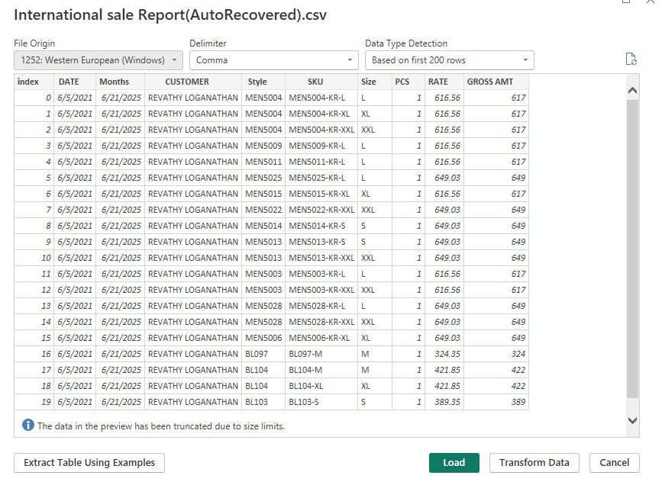
Fig. 1:

- PowerQuery Window

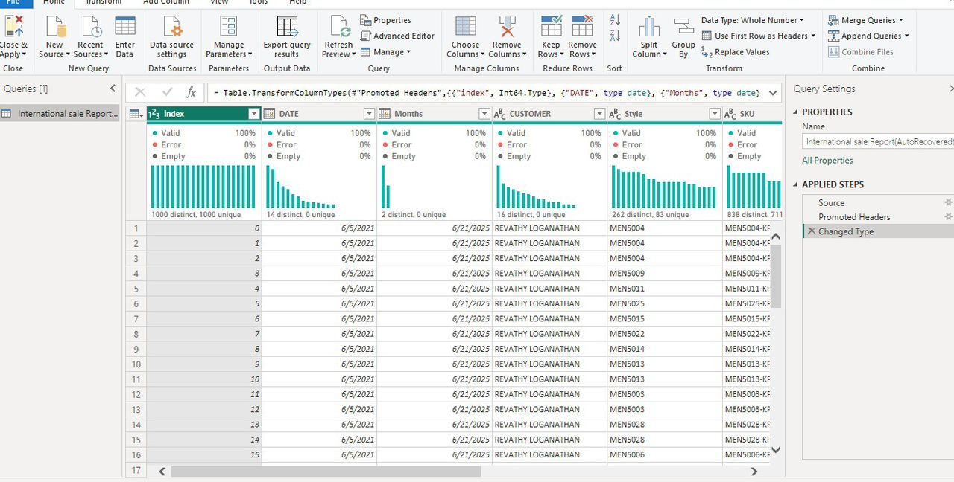
Fig. 2:
- Separate the original dataset into two tables:
Table 1, contains data from the top of the table up till index number 18634
Table 2, contains data from index number 19676 to the last entry on the table
Changed the datatype of the date column to date by forcing the date datatype to recognise some records that were inputted as text instead of numbers:
Data -> text to column -> delimited -> space -> date -> MDY -> finish

Deleted the month column on both tables and the stock column on the second table
Used the CONCATENATE function to fill the missing SUKs on the first table by concatenating the style and the size columns of those missing SKUs
Extracted the data to Power Query where further cleaning was carried out
Rearranged the column arrangement on the second table to match the arrangement on the first table
Made sure the font case for the columns was the same on both tables
Added a size column for the second table by extracting the last text after the delimiter on the records of the SKU column on the second table:
After making sure both tales have the same columns and column arrangements, the tables were then appended using the append query function.
Then other transformations were done like standardising the font case of each column, taking care of incorrect values.
Then duplicate values were removed by using three columns (date, customer, and SKU)as references since the table does not have a primary key.
The data was then loaded into power BI
Then a date table was created:
Home New table type: DateTable = CALENDARAUTO() Enter
Then create new columns for month, day of the week, and year:
New column Type: Month = FORMAT (DateTable[Date], “MMM”) Enter
New column Type: Days = FORMAT (DateTable[Date], “DDD”) Enter
New column Type: Year = (DateTable[Date], “MMM”) Enter
This new date table will help us calculate revenue per month per year and total sales per month per year and so on

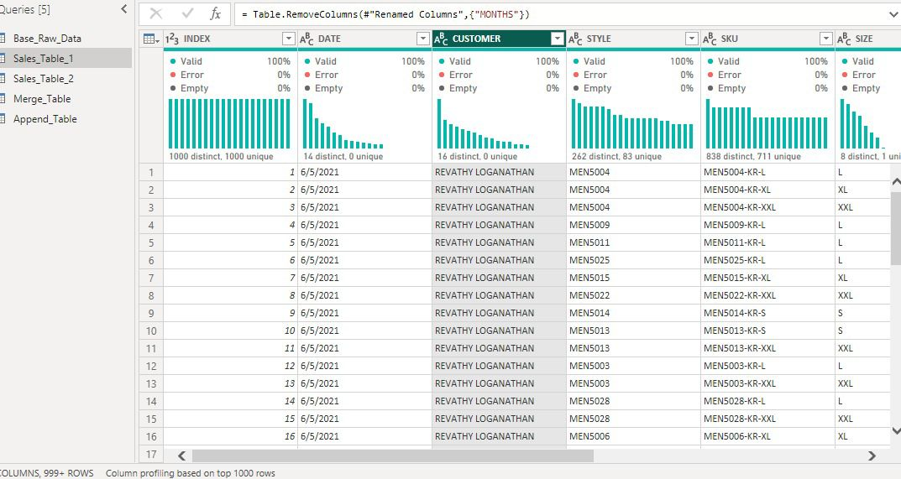
Fig. 3:

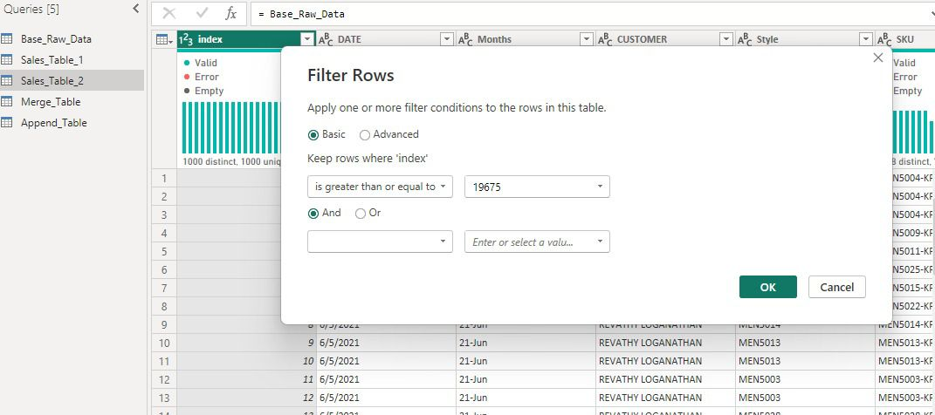
Fig. 4:
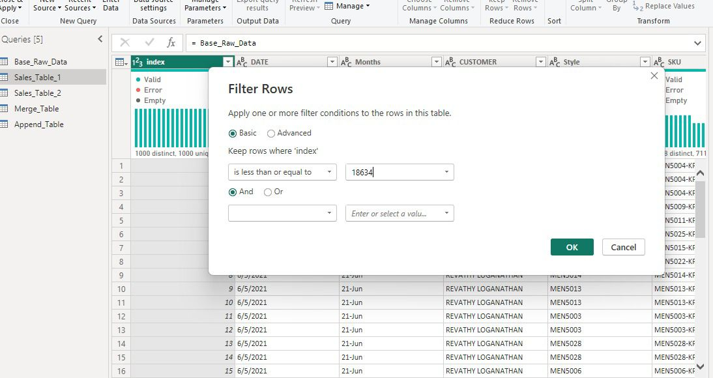
Fig. 5:
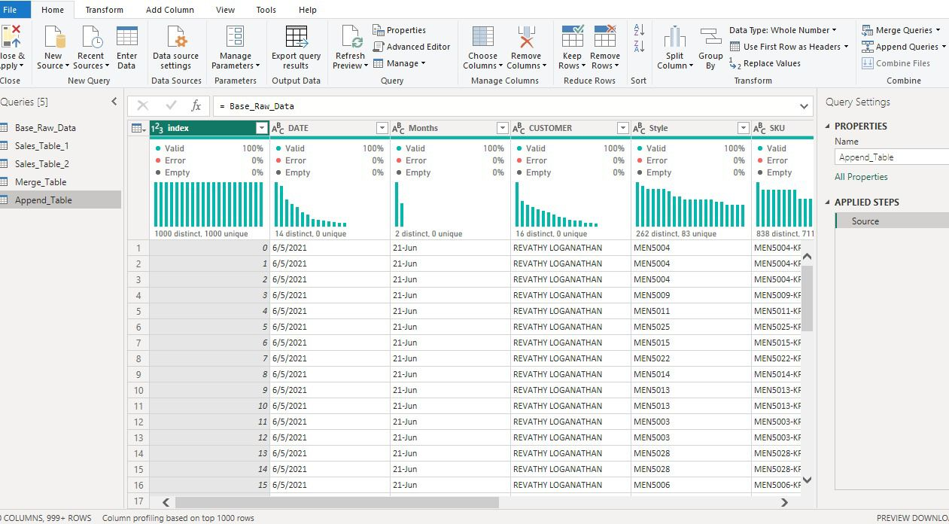
Fig. 6:
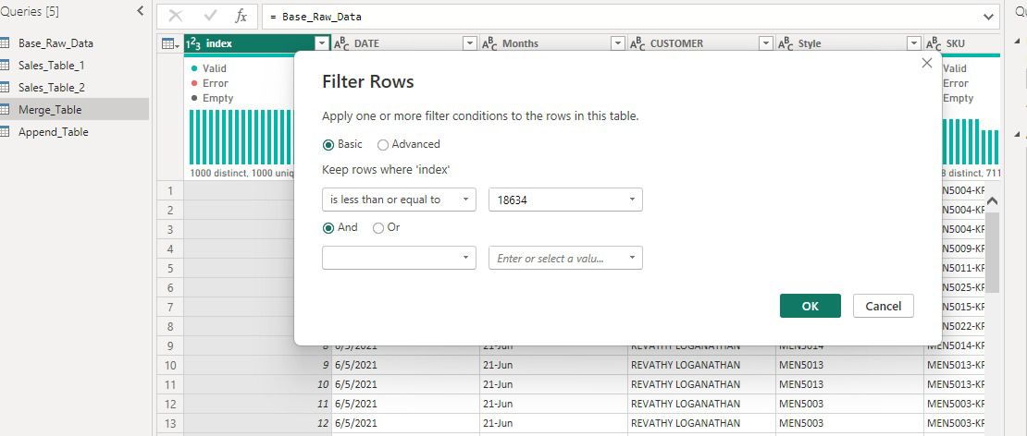
Fig. 7:
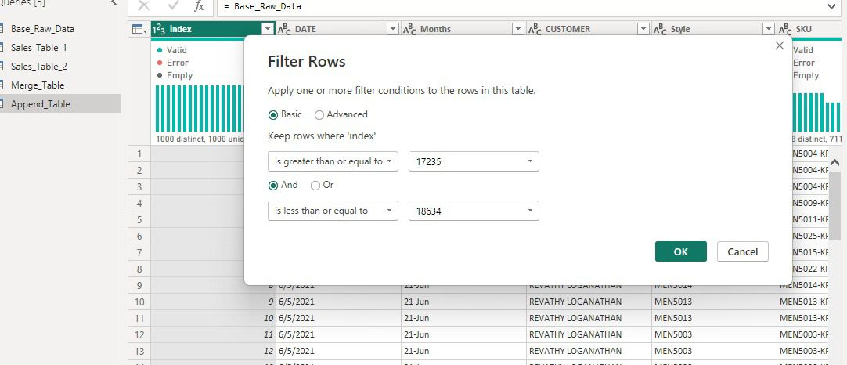
Fig. 8:
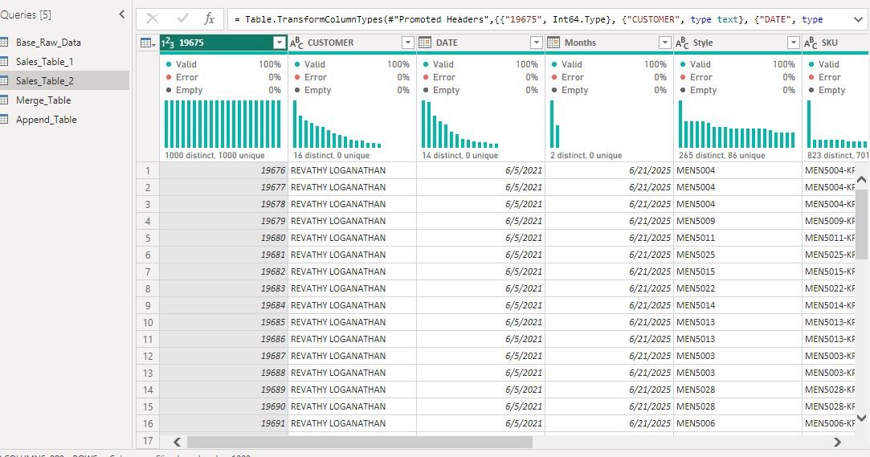
Fig. 9:
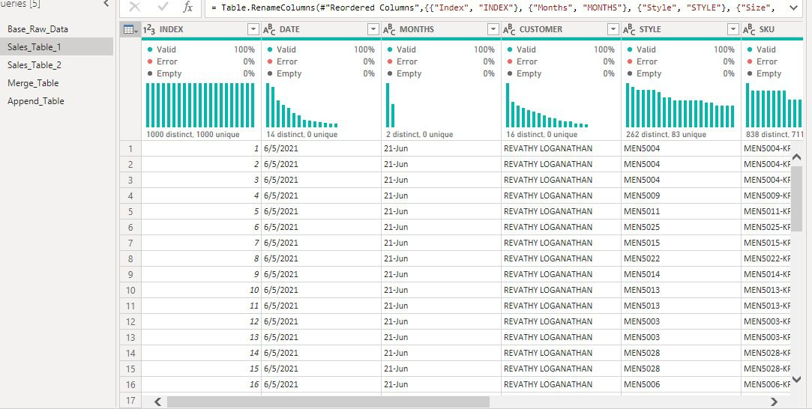
Fig. 10:

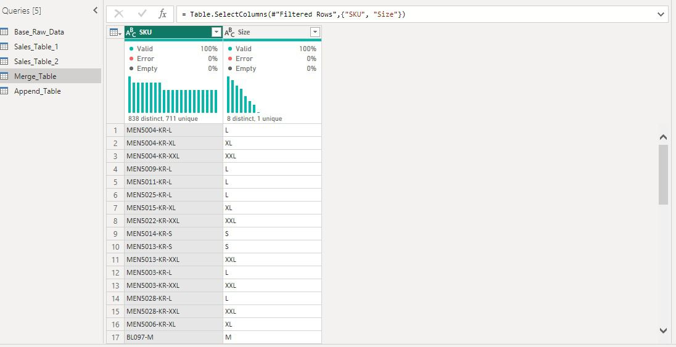
Fig. 11:
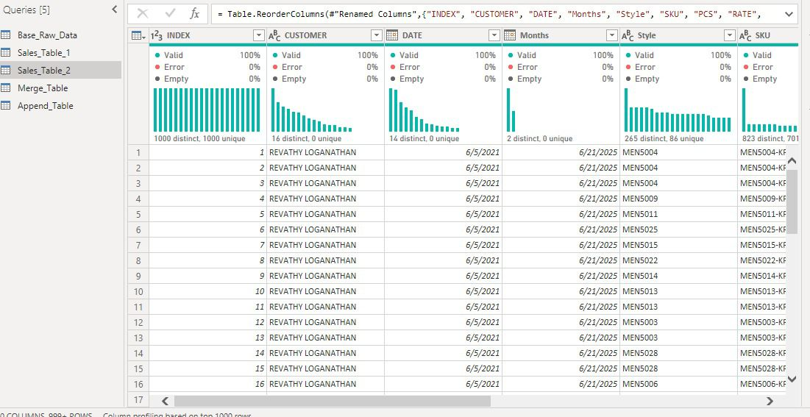
Fig. 12:

Fig. 13:
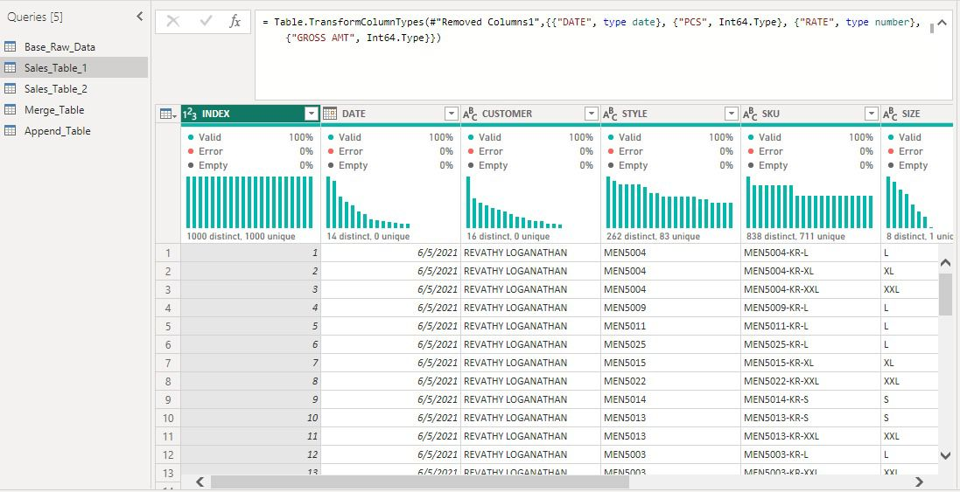
Fig. 14:
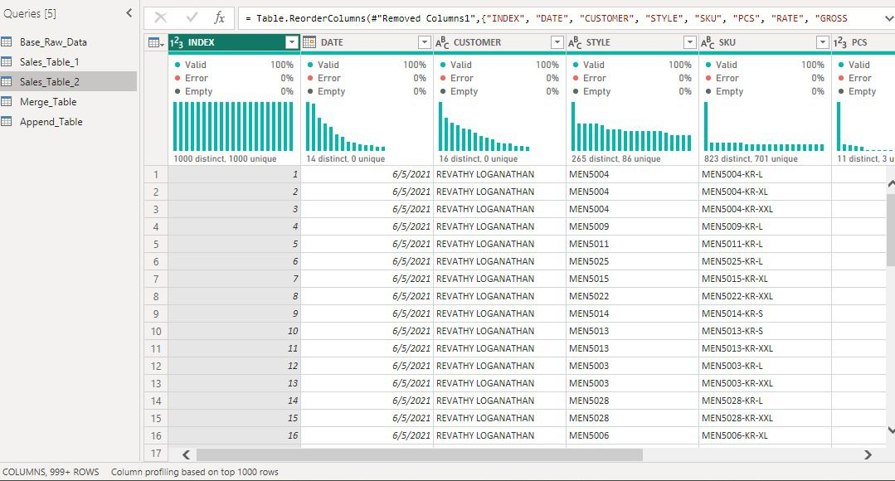
Fig. 15:

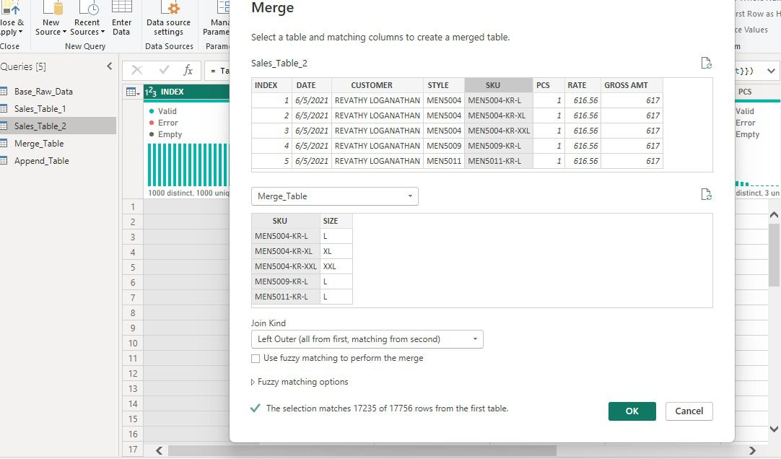
Fig. 16:

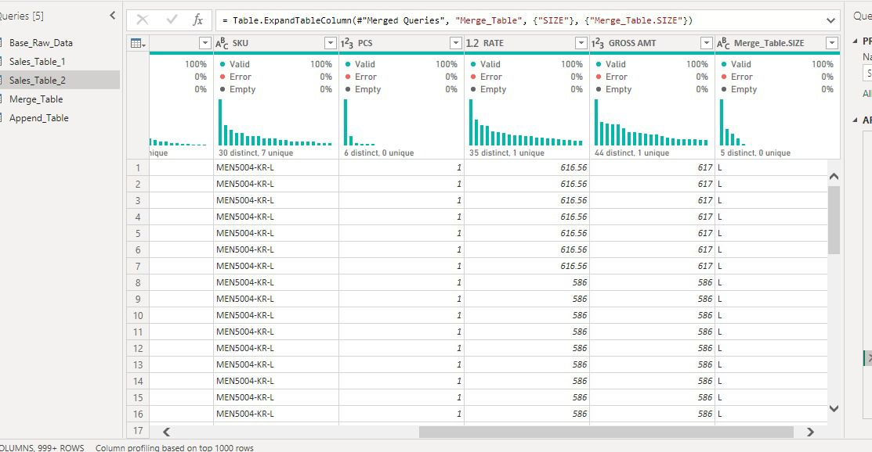
Fig. 17:

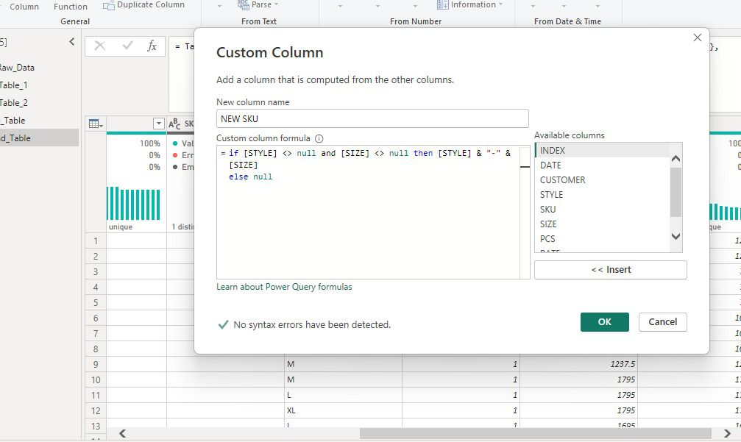
Fig. 18:

Fig. 19:
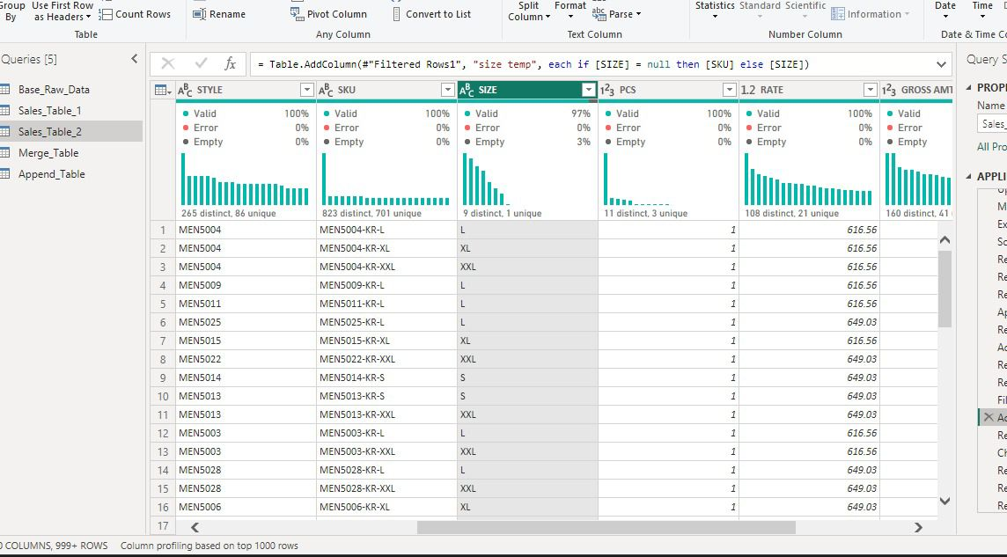
Fig. 20:

Fig. 21:
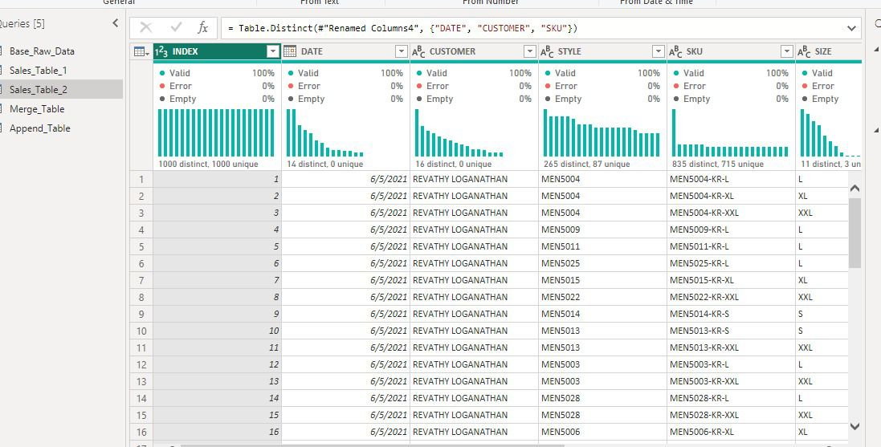
Fig. 22:

Fig. 23:
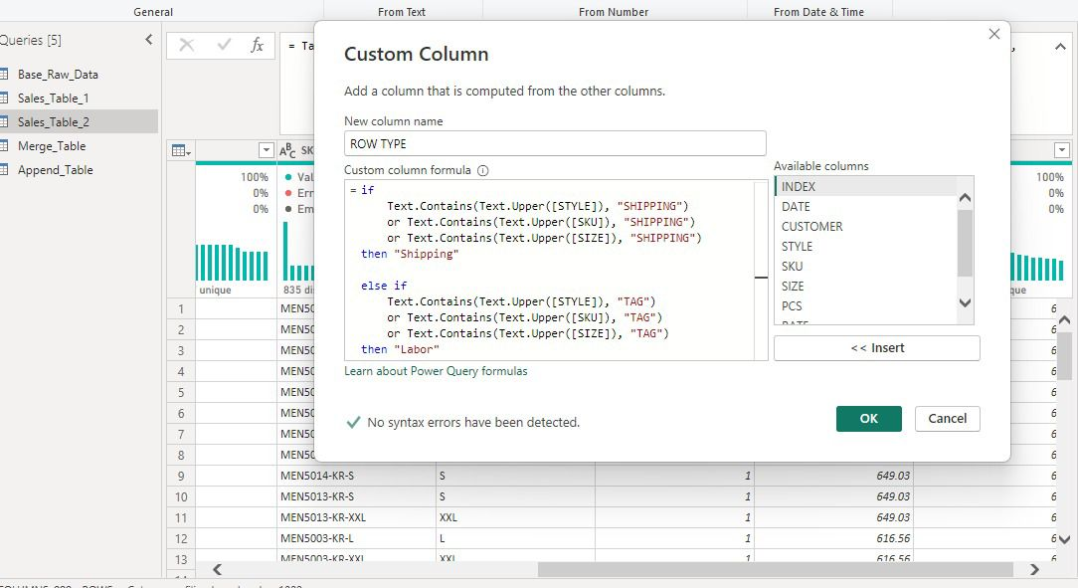
Fig. 24: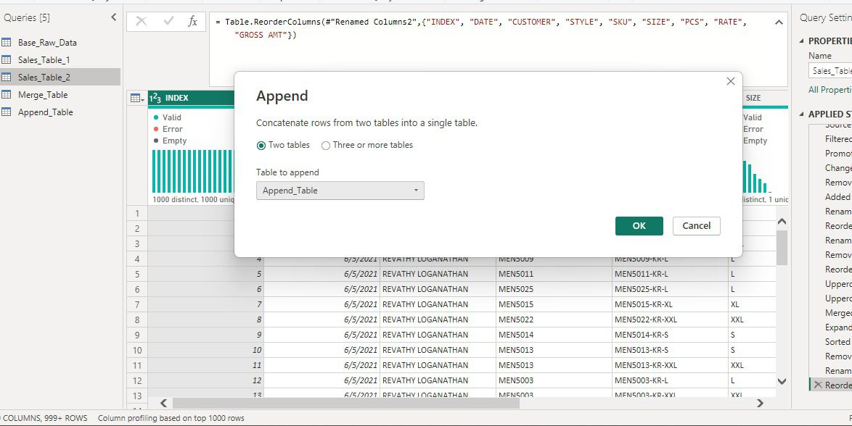
Fig. 25:

ANALYSIS USING POWER BI
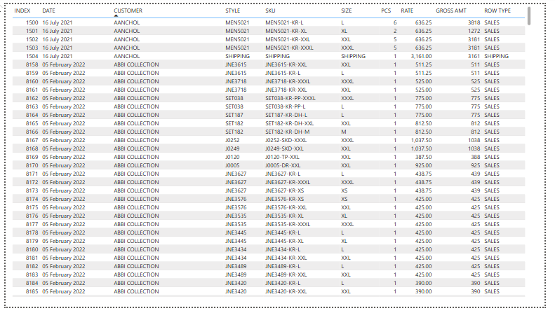
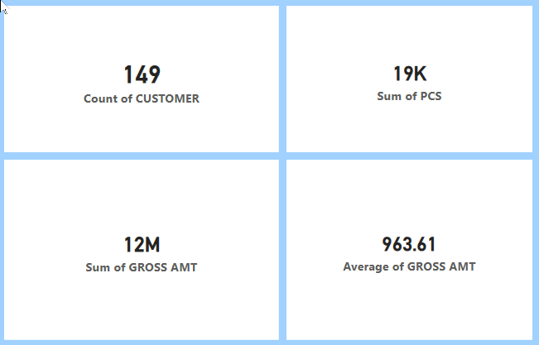
Fig. 27:

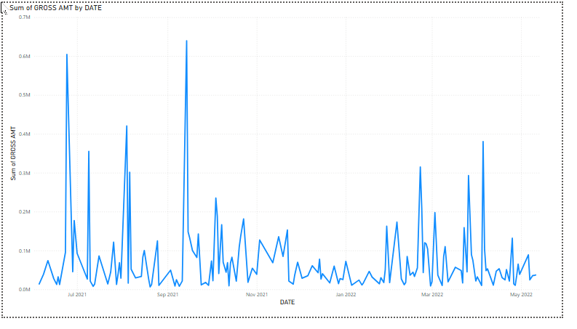

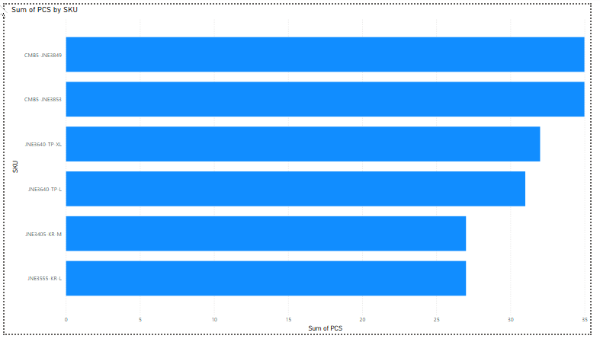

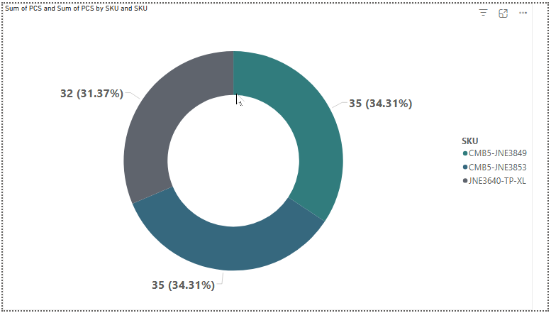

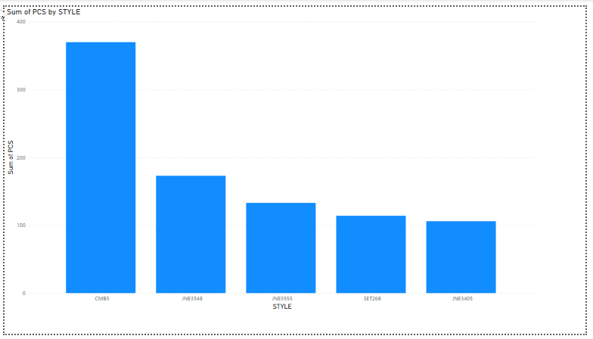

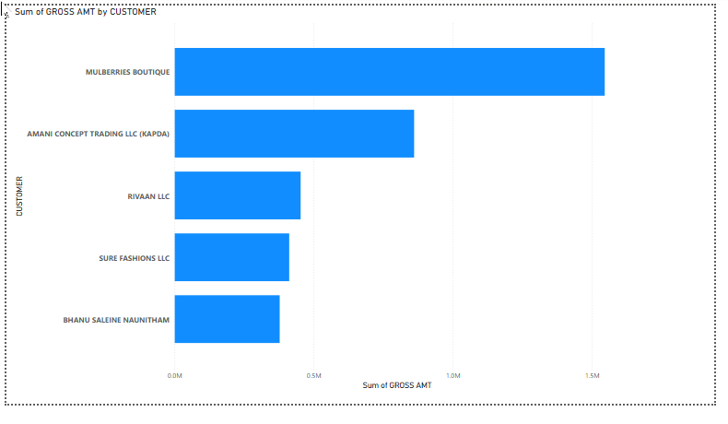

CONCLUSION
To address the severe structural issues identified, a comprehensive data cleaning activity was performed.
This involved:
- Structural Reconstruction: Developing logic to handle "shifted" rows where date and customer columns were swapped.
- Data Normalization: Standardizing case, trimming whitespace, and parsing mixed date formats.
- Missing Value Resolution: Dropping unrecoverable records and applying defaults.
- Type Coercion: Converting financial and volumetric fields to numeric types for analysis.
Salient Insights Post-Cleaning
The transition from a "dirty" to a "cleaned" dataset revealed several high-impact business insights:
- Customer Concentration: A staggering 72.4% of total revenue is driven by just the top 5% of customers, indicating a high reliance on key boutique accounts (e.g., MULBERRIES BOUTIQUE).
- The 80/20 Product Rule: Out of hundreds of apparel styles, only 168 styles account for 81% of revenue, highlighting a significant Pareto distribution in the inventory.
- Size Dominance: Market demand is heavily skewed toward mid-range sizes, with L (24.3%), XL (22.1%), and M (18.7%) dominating over 65% of the total sales volume.
- Seasonal Volatility: Retail activity shows extreme peaks in June 2021 and Sept 2021, suggesting specific windows for high-volume inventory turnover.
In conclusion, while the raw International Apparel Sales Data was initially unfit for decision-making, the subsequent cleaning and transformation process successfully converted it into a high-fidelity dataset. The primary recommendation for future data collection is the implementation of strict schema validation to prevent the "categorical chaos" and structural shifts observed in this analysis.

